Tyrone Middle School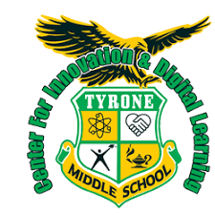

Today a reader, tomorrow a leader

*Summer Reading*

*Scholars are expected to choose one book from the approved State of Florida Sunshine State Young Readers program.*

*Outside of online and local booksellers, we encourage scholars to take advantage of their local libraries and online libraries like Libby and Sora).*

*Scholars will be expected to complete one of the activities of their choice from the backside and will be due* ***August 23rd, 2024 (two weeks from the start of the 2023-24 school year).***

*Please sign and return:*

*I am aware of the summer reading expectations. If the activities options sheet gets misplaced, the information will be available on the Tyrone Middle School website.*

*_____________________________________________________*

*(Parental/Guardian Signature)*

*_____________________________________________________*

*(Scholar Name, printed)*

|  |  |
| --- | --- |
|  | *By checking this box, you are opting out of the SSYRA book list and your child will read*  *______________________________________________________________________________ (please write the* ***grade level*** *book on this line).* |

*Summer Activity*

*(choose one)*

Write a poem or song lyrics that connect to your novel. Focus on the plot, characters, and/or personal connections you have with the novel. (*30 lines or longer with a minimum of four **figurative language** uses)

Write a letter to the author of your chosen novel. Explain what you liked and/or disliked, ask any questions you have about the story/characters, explain what you would have changed if you were the author, and mention at least one thing you will always remember about this novel and why. (*at least one full page, typed, and written in letter format)

Create a poster or video detailing the plot of your novel. Include descriptions of the events in the exposition, rising action, climax, falling action, and resolution. Write a statement of the main theme with 2 cited quotes from the novel for support. The poster should include illustrations and a border.

Create a cartoon/storyboard (minimum of 8 panels) based on your novel. Focus on pivotal events and put them in chronological order. (Can be digital)